Chapter 3: Architecture design and algorithm explanation
The project structure follows the industry-standard pattern for web applications of a three-tier, client-server architecture. The three tiers are the frontend presentation layer, built with React.js, the application layer, built with Express/node js, and the database layer built with PostgreSQL.
This architecture offers the following advantages^{1,2,3}
Separation of concerns. The user interface, business logic, and database can be developed, maintained, and tested independently without interfering with each other.
Scalability. As demand increases, additional servers can be added to handle more users and requests, but this has a cost disadvantage.
Security. The frontend cannot directly communicate with the database; instead, all requests are routed through the application layer which runs validation, authentication and authorisation checks as well as error handling. Only if business logic requirements are met will a database operation be performed.
Building such a large project requires numerous development tools for front-end, back-end , and the database. The chosen tools and reasoning are as follows:
React.js
React is a modern, well-maintained, well-documented, and in-demand library with numerous add-on libraries designed to extend functionality. It is built around the paradigms of component-based-architecture and single-page applications where developers create re-usable UI components that efficiently update in response to data changes. React also integrates well with express.js.
React router
React router is a library specifically designed to simplify client-side routing in react. It allows dynamic navigation and nested routes as well as handling data fetching and loading for components.
React hook form and Zod
React-hook-form is a library specifically designed to simplify the implementation of user forms in react. It reduces re-renders and integrates easily with schema validation libraries like Zod.
Tailwind CSS
Tailwind is a popular CSS framework that integrates particularly well with react. It is used to create modern, responsive UIs using pre-defined classes for styling. It will reduce the need for custom CSS.

Express JS
Express JS is one of the most popular frameworks for building web servers and APIs. It greatly simplifies routing compared to node.js and, like react, has many libraries to extend functionality or take care of security e.g. passport, bcrypt. It integrates easily with databases like PostgreSQL.
PostgreSQL
PostgreSQL was chosen primarily as it is a relational database that lends itself well to structured, relational data and integrates easily with express via the ‘pg’ library. MongoDB was excluded as it is noSQL.

Project structure
The project structure has individual frontend and backend code folders within a master folder as shown in fig 3.1
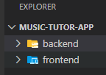
Fig 3.1 High-level folder structure.

Backend Overview
The backend folder structure is shown in fig 3.2. The backend runs from the server.mjs file. Supporting code is modularised into separate folders and subfiles whose functionality can be imported as required.
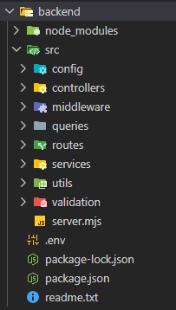
Fig 3.2 Backend folder structure
Server.mjs file
This file imports environment variables using the dotenv package, initialises the express and socket.io servers and configures CORS for both. It also sets up middleware to allow parsing of JSON-formatted client requests cookie parsing for use with JWT authentication, and to support real-time chat functionality via socket.io middleware and event listeners. Dedicated routers with associated handlers are imported to handle client HTTP requests, and a global error handler is set up to shape errors before sending to frontend. Code is shown in figs 3.3. and 3.4 below.
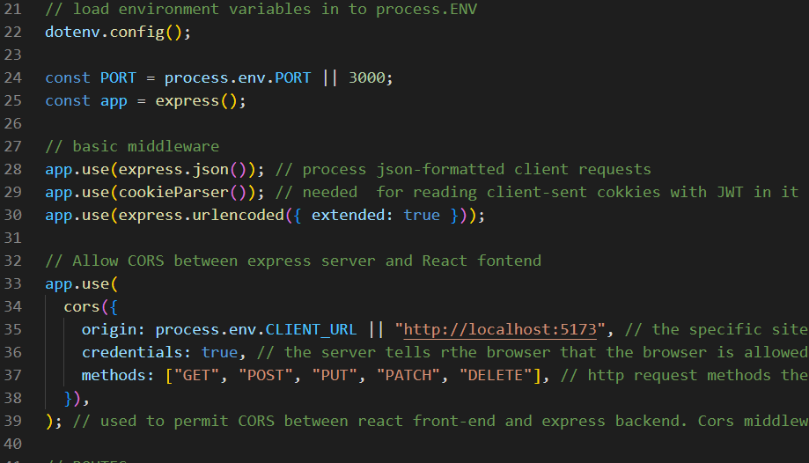
Fig 3.3 Initiation of and CORS configuration for express server, and middleware setup.
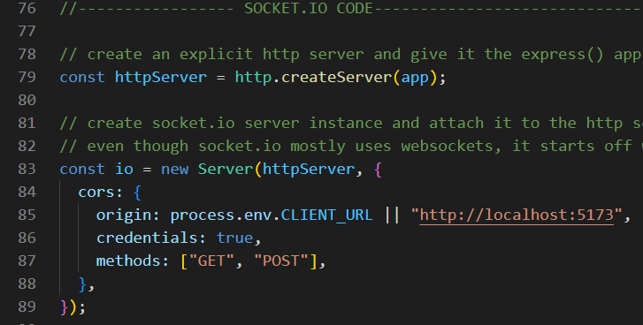
Fig 3.4 Socket.io server instantiation and CORS configuration
Server.mjs also sets up authentication middleware along with event listeners and emitters for socket.io which enables both chat history and real-time chat notification and messaging. See appendices for code snippets.

Config
The config folder contains the pool.mjs file which is responsible for establishing database connection. It uses the Pool module from the pg express package as well as environment variables via dotenv to supply the needed connection information. It also exports a custom wrapper function called query that is used extensively for parameterised database queries.
Controllers
This folder contains modularised controllers for handling requests to API endpoints. The modularised approach was employed as some endpoints have complicated business logic. Controllers have been classified by endpoint type e.g. authController.mjs for authorisation, registrationControllers.mjs for registration etc.
Middleware
This folder contains authMiddleware.mjs which defines the protect middleware for protecting routes so only logged-in users with a valid JWT can access them. It also contains the globalErrorHandler function used in server.mjs.
Queries
This folder contains many parametrised SQL queries in .sql files. The load.sql function is defined here; it is used to read the .sql files and convert them to text for use with the query function.
Routes
Routes defines routes on and exports all the dedicated routers used in server.mjs. Each router file will import the relevant controllers from the controllers folder.
Services
TokenServices.mjs defines and exports the signUserToken and verifyToken functions used for JWT auth. UserServices.mjs defines functions for funding users in the database by user id or email, validating input passwords against the database’s stored hashed passwords, and the buildUserInfo function that adds validated user information to the req.user and socket.user objects for authenticating requests and webchat.
Utils
Cookie.mjs defines cookie options and the setAuthCookie function that adds the signed auth token into express’s response object. utilFunctions.mjs defines and exports a function for generating a unique room number from student and tutor user ids for use in the frontend;s webchat components and for database persistence.
Validation
Contains basic form validation schemas for student, tutor, and admin registration.

